The Cartagena Protocol on Biosafety to the Convention on Biological Diversity is an international treaty governing the movements of living modified organisms (LMOs) resulting from modern biotechnology from one country to another. It was adopted on 29 January 2000 as a supplementary agreement to the Convention on Biological Diversity and entered into force on 11 September 2003.

Cartagena Protocol
The full name of the treaty is Cartagena Protocol on Biosafety to the Convention on Biological Diversity.
- The international treaty concerns the movement of LMOs (living modified organisms) resulting from modern technology from one nation to another.
  - LMOs are defined under the protocol as living organisms that have a novel combination of genetic material secured from the use of modern technology.
- It is a supplementary agreement to the CBD like the Nagoya Protocol.
- The Protocol was adopted in 2000 and it came into force in 2003. The protocol was adopted in Montreal in 2000 but is named after Cartagena, the original city in Colombia where the protocol was supposed to be adopted. It was delayed due to some outstanding issues.
- The Cartagena Protocol on Biodiversity seeks to protect biodiversity from the potential risks caused by LMOs arising from modern technology.
- The protocol was adopted because of the tremendous advancements in biotechnology and the associated concerns about its safety and usage with respect to biodiversity.
- It seeks to implement an internationally harmonised regime for biosafety in order to ensure the safe utilisation of modern biotechnology.
- The Protocol has provisions for an Advance Informed Agreement (AIA) procedure.
  - The AIA is for ensuring that countries are given enough information to make informed decisions before agreeing to import LMOs into their country.
  - There are four components to the AIA:
    - Notification by the exporter (This is a detailed written description of the LMO by the exporter, well in advance of the first shipment)
    - Acknowledgement of notification receipt by the importer
    - Decision procedure (Approve/prohibit/ask for more information, etc.)
    - Review of decisions
- The Cartagena Protocol also sets up a Biosafety Clearing-House (BCH) to enable information exchange on LMOs between countries.
  - It is also intended to help countries implement the Cartagena Protocol.
  - The BCH is an information-sharing mechanism for relevant technical, scientific and legal information.
- The Protocol gives a precautionary approach to the issue of transfer of LMOs from one country to another.
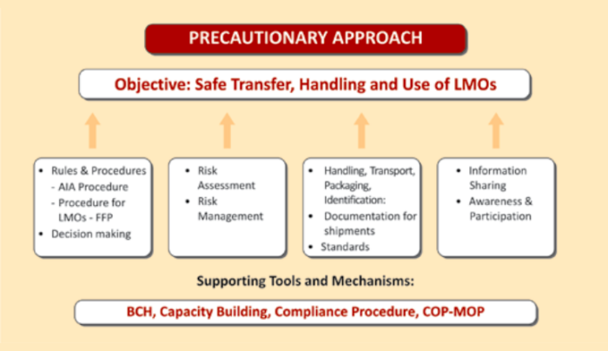
The Conference of the Parties serving as the meeting of the Parties to the Protocol (COP-MOP)
Advance Informed Agreement" (AIA)
food or feed, or for processing(FFP)
Source: GEAC

Cartagena Protocol Scope
The Protocol is applicable for transboundary movement, transit, handling and use of all LMOs that may have harmful effects on the conservation and sustainable use of biological diversity, also considering risks to human health.
- The Cartagena Protocol chiefly governs the following:
  - LMOs that are intentionally introduced into the environment (trees, seeds or fish).
  - Genetically modified (GM) farm commodities (grain and corn used for animal feed, food or for processing).
- It does not cover pharmaceuticals for humans addressed by other international agreements and organisations or products derived from LMOs, such as cooking oil from GM corn.
- LMOs are classified as the following under the Protocol:
  - LMOs for intentional introduction into the environment – subject to AIA procedures.
  - LMOs for direct usage as food or feed, or for processing – subject to simplified procedures which include informing through the BCH.
  - LMOs for contained usage (like bacteria for lab experiments) – these are exempt from AIA procedures.

Cartagena Protocol and India
India is a party to the Cartagena Protocol (ratified in 2003). The nodal agency (Competent National Authority-CNA) in the country for the implementation of the Protocol is the Ministry of Environment, Forest and Climate Change (MOEF&CC), Government of India.
- Regarding setting up of procedures for regulating LMOs, India was one of the early movers in the development of a biosafety regulatory framework, way back in 1989, and has a systematic and structured science-based regulatory system.
- In the Indian regulations, the terms Genetically Engineered Organism or Genetically Modified Organism are used, which are synonymous with LMOs.
- In India, series of guidelines are available for risk assessment and risk management of GMOs.

Elements of the Strategic Plan for the Cartagena Protocol on Biosafety

Vision | - | Mission
Strategic Objectives |  | Operational Objectives
Focal area 1 : Facilitating the establishment and further development of effective biosafety systems for the implementation of the Protocol |  | - National Biosafety Frameworks  - Coordination and support  - Risk assessment and risk management  - LMOs or traits that may have adverse effects  - Liability and Redress  - Handling, transport, packaging and identification  - Socio-economic considerations  - Transit, contained use, unintentional transboundary movements and emergency measures
Focal area 2 : Capacity building |  | - National Biosafety Frameworks  - Risk assessment and risk management  - Handling, transport, packaging and identification  - Liability and Redress  - Public awareness, education and participation  - Information sharing  - Biosafety education and training
Focal area 3 : Compliance and review |  | - Compliance with the Protocol  - Assessment and review
Focal area 4 : Information sharing |  | - BCH effectiveness  - BCH as a tool for online discussions and conferences  - Information sharing other than through the BCH
Focal area 5 : Outreach and cooperation |  | - Ratification of the Protocol  - Cooperation  - Communication and outreach

